Bayou Bartholomew
Watershed Plan
2009 Update

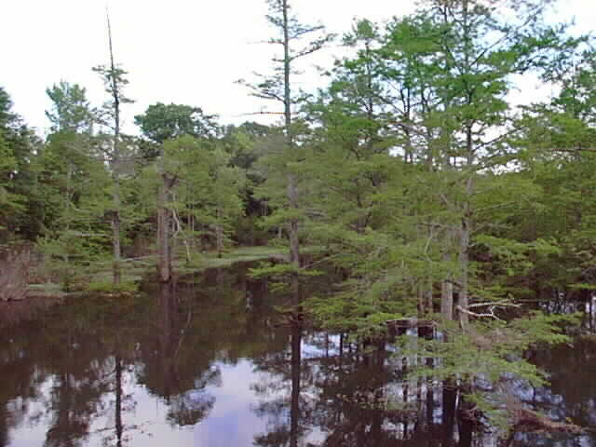
Table of Contents

Watershed Description 3
Location and Physical Setting 3
Landscape and Topography 3
Geomorphology 4
Hydrography 4
Hydrology 5
Groundwater 6
Soils 7
Vegetation 7
Wetlands 8
Fish and Wildlife Resources 9
Demographic and Socioeconomic Characteristics 10
Water Quality 12
Element 1: Identification of Causes and Sources 13
Element 2 & 3: Proposed Management Measures & Estimated Load Reductions 15
Element 4: Technical and Financial Assistance Needs 17
Technical Assistance 18
Element 5: Information, Education, and Public Participation 19
Element 6 & 7: Schedule and Milestones 19
Element 8: Performance Criteria 21
Element 9: Monitoring Component 21
Literature Cited and/or Reviewed 23

Watershed Description

Location and Physical Setting

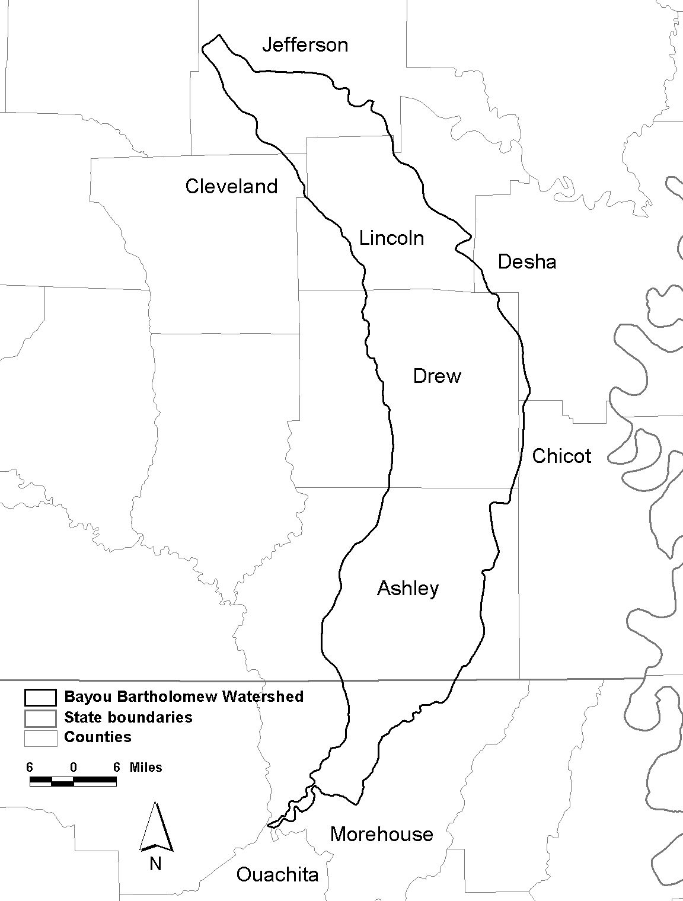
The Bayou Bartholomew Watershed is located in the southeastern Arkansas and northeastern Louisiana. The Bayou Bartholomew is the main stream found within the watershed. It flows for 269 miles through six counties in Arkansas and Morehouse Parish in Louisiana. Counties in Arkansas through which the stream flows include Jefferson, Lincoln, Drew, Ashley, Desha, and Chicot Counties. Small portions of the latter two counties are within the watershed. The extreme northeastern corner of Cleveland County is within the watershed; however, the stream does not flow through that county (Figure 1).

The western edge of the watershed, to the west of the Bayou Bartholomew, lies within the West Gulf Coastal Plain Natural Division. The eastern side of the watershed is within the Mississippi Alluvial Plain Natural Division. The Bayou Bartholomew lies on the boundary between these two ecoregions, thus comprising a diverse ecotone as related to the aquatic community, which it harbors. Consequently, differences in stream characteristics, land use, vegetation, and wetland types are found between east and west portions of the watershed. Flat farmlands characterize the eastern watershed while rolling forested hills predominate in the western part of the watershed.
Figure 1. Bayou Bartholomew Watershed.

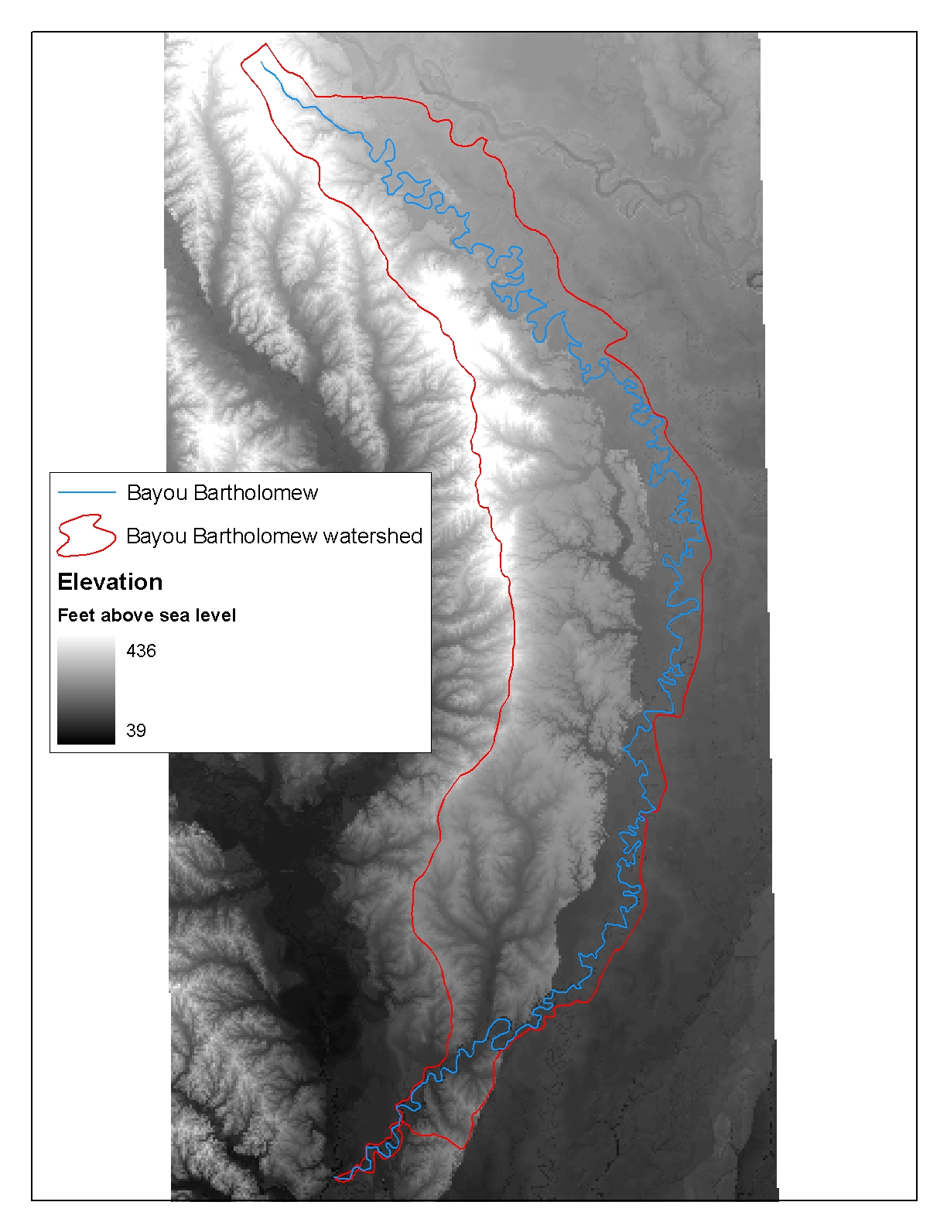
Landscape and Topography

Land formations within the watershed are the result of the actions of both wind and water, both of which contributed to cyclic soil erosion and deposition. Alluvial deposits of the Mississippi and Arkansas Rivers were the predominant causes of soils found in the eastern portion of the watershed. Slopes of less than one percent characterize this area while elevations range from 100 to 400 feet above sea level (USDA 1975, 1976, 1979, 1980). In the southwestern, south central, and to some degree the center portion of the watershed extending far northward in the watershed, soils originated from loess (windblown) deposits. Usually these areas also have slopes of less than one percent though some ridges occur with up to eight percent slopes. Elevations where loess occurs are from 150 to 500 feet above sea level. Ancient marine deposits are also found in the northwestern portion of the watershed with slopes ranging from one to eight percent and occasionally up to 12 percent (Figure 3).
Figure 2. Elevations range up to 439 feet above sea level in the watershed.

Geomorphology

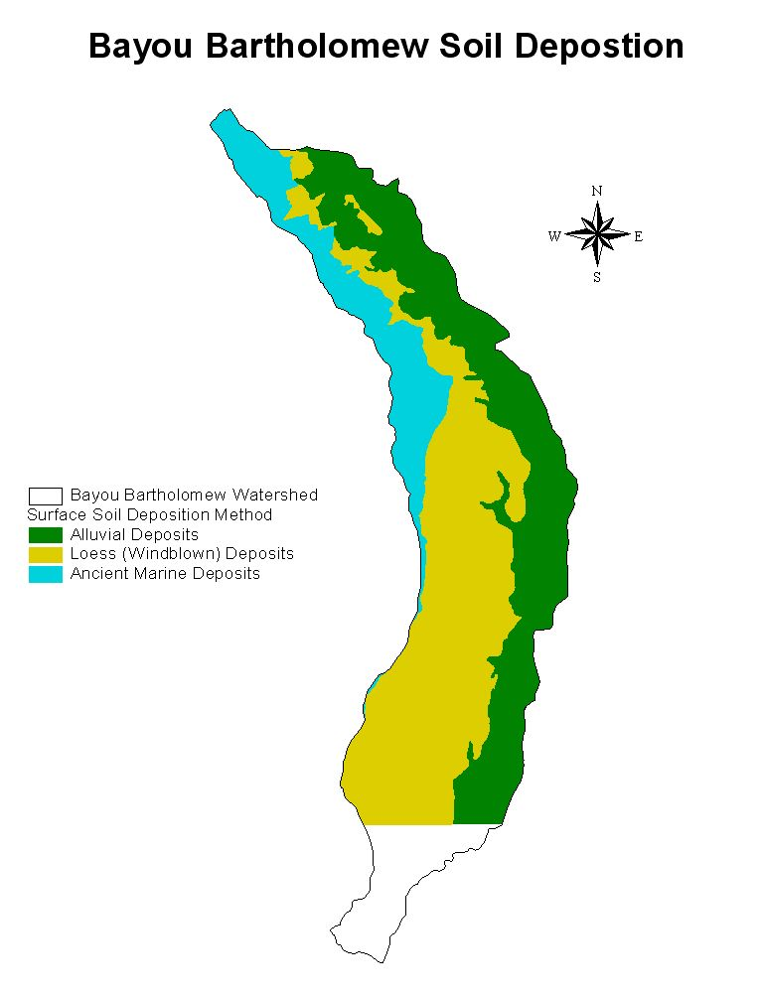
Melt waters from glaciers greatly influenced the topography of the watershed. Glacial flows deposited sediments from north and west of the watershed into the area known as the Lower Arkansas River Alluvial Valley. Between Little Rock, Arkansas and the Mississippi, some six meander belts of the Arkansas River have been identified (Saucier 1994). The Bayou Bartholomew in its present-day location occupies one of these meander belts. Most of the oxbow lakes found along the Bayou Bartholomew were formed when the Arkansas River occupied the present day Bayou Bartholomew channel. This is thought to have occurred some 2,000 years before present.

Many sandy and silty soils were deposited as point bars and natural levees by this prehistoric river channel. Areas outside the initial deposition zone, but still within the floodplain, referred to as back swamps, had silt, clays, and other fines deposited as a result of overland flooding.

These late Pleistocene and Holocene alluvial features were deposited in areas where the higher and older Prairie terraces had been eroded away. The Prairie Terrace consists of glacial melt and alluvial deposits laid down earlier in the Pleistocene, and overlain with windblown loess deposited by prevailing winds (Saucier 1994). This terrace is higher than the late Pleistocene and Holocene alluvial terraces, and still exists in the watershed in the form of isolated patches within the alluvial plain, and in the silty uplands west of the alluvial plain.
Figure 3. The surface soils found in the Bayou Bartholomew watershed are placed in three categories based on their method of deposition.

The coastal plain lies to the west of the silty uplands and encompasses portions of the northwestern portion of the watershed. It is composed of ancient marine deposits little affected by rivers except for more recently formed flood plains of small streams.

Hydrography

A network of streams, bayous, ditches, oxbow lakes, and-made reservoirs is found within the watershed (Figures 4 and 5). Dendritic stream patterns occupy the western coastal plain portion of the watershed while meandering stream patterns are found in tributaries to the Bayou Bartholomew entering from the delta. The Bayou Bartholomew retains its sinuosity in a somewhat natural state while some of its tributaries on the eastern side have seen extensive channel alteration. Major tributaries to the Bayou Bartholomew include Deep Bayou, Cousart Bayou, Ables Creek, Cutoff Creek, Bearhouse Creek, Chemin-a-Haut Creek and Overflow Creek.
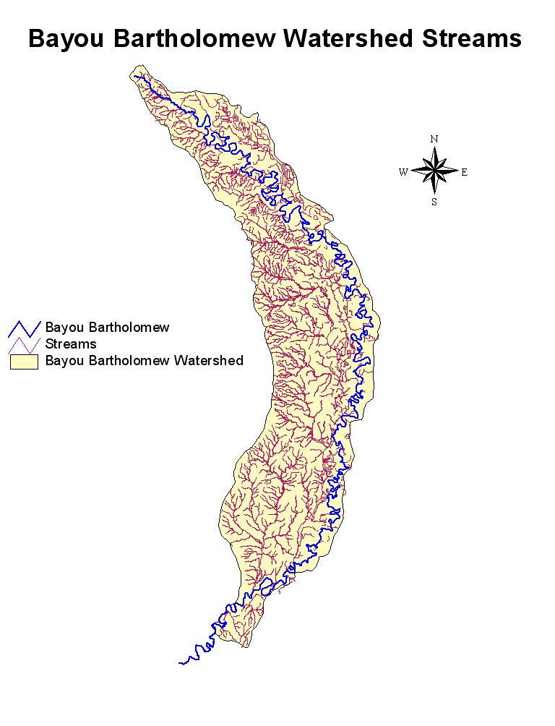
The majority of lakes found within the watershed are oxbow lakes that were formed by the meandering of the Arkansas River during its occupancy of the Bayou Bartholomew Meander Belt. A number of man-made lakes, both public and private, are used for fishing and waterfowl hunting. Cane Creek Lake is a man-made impoundment on a tributary of the Bayou Bartholomew. Seasonal impoundments are found on state and federal lands used principally for hunting and include Seven Devils Wildlife Management Area (WMA), Cutoff Creek WMA, and the Overflow National Wildlife Refuge. The Arkansas Game and Fish Commission own or leases several naturally formed oxbow lakes managed primarily for fishing. These include Lake Wallace, Lake Grampus, Wilson Brake, and Lake Enterprise. Lakes range from 150 to 300 acres in size (AGFC 2001).
Figure 4. A network of streams interlaces the Bayou Bartholomew Watershed. The Bayou Bartholomew follows the eastern side of the watershed, essentially separating the Gulf Coastal Plain and the Delta Ecoregions.

Hydrology

A number of activities both within and outside of the watershed have altered the hydrology of the watershed in the past century and a half. Dams, weirs, levees, channelization, draining and filling of wetlands, and removal and/or addition of water to stream channels have resulted in hydrological changes.

Streams and aquifers in the watershed are intimately connected. Changes in stream flow or stage of a stream result in changes in the head, or flow, in related aquifers (Broom and Reed 1973). The natural sinuosity of the Bartholomew is pointed out by its length, traveling some 279 miles to the Louisiana border, an actual straight-line distance of 90 miles. Channel slopes average approximately one-half foot per mile. Most streams occurring in the Mississippi River Alluvium are described as gaining streams. USGS (1969) determined during dry periods, the Bayou Bartholomew gained 45.5 cubic feet per second between Pine Bluff in its upper end to the Louisiana border. Seventy-five percent of that gain occurred downstream of McGehee far to the south. Spring and fall potentiometric maps of aquifers in the area indicate that the Bayou Bartholomew is primarily a drain for groundwater flow from the west and a recharge source for aquifers to the east. The Arkansas River at high flows is also a recharge area for the aquifers to the east of the Bartholomew, thusly affecting water levels in the Bayou Bartholomew.
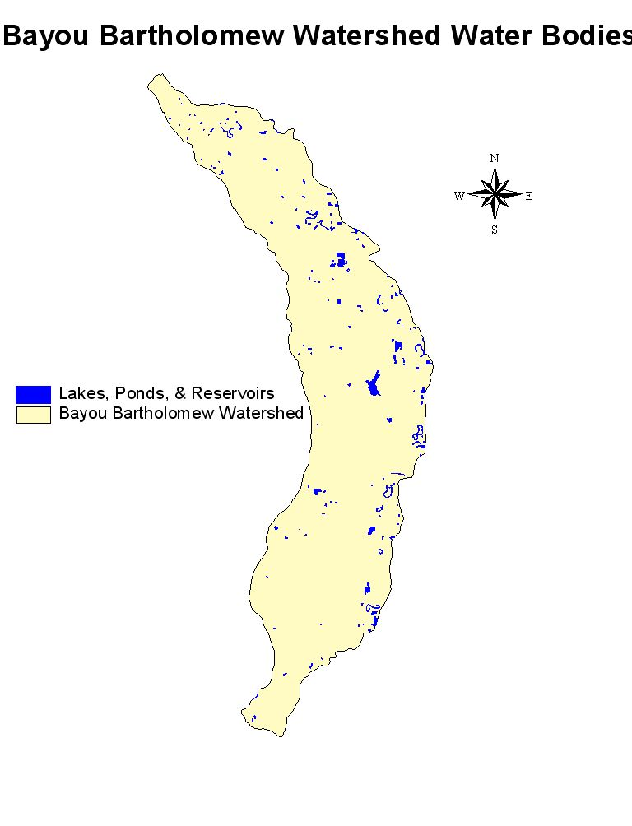
The Bayou Bartholomew and its tributaries carry their highest flows during the months of January through May, due to higher rainfall events during those times. Minimum flows usually occur during the period from August to October (ASWCC 1987, 1988). Natural flow regimes have been drastically altered by removal of water for irrigation, with some 87 percent of the available surface water in the stream being removed during summer (ASWCC 1987). Layher and Phillips (2000) calculated minimum flow values needed at points in the Bayou Bartholomew to maintain historical levels of fisheries based on existing hydrological records for the stream. The majority of the watershed has been declared a critical surface water area (ASWCC 1990).
Figure 5. Many natural and man-made water bodies are found throughout the watershed.

More farmers in the area have turned to surface water in the watershed as a result of aquifer declines in the area. This has further reduced surface water flows in the Bartholomew. The U. S. Army Corps of Engineers is currently studying the feasibility of pumping Arkansas River water into the Bayou Bartholomew to augment flows to supply
farmers in Southeastern Arkansas with irrigation water. This action will further affect hydrology of the watershed. Layher and Phillips (2001) further emphasize that potential benefits of the proposed alteration should be evaluated with regard to any potential negative impacts and recommend examining more efficient irrigation methods, dry crop alternatives, and off stream reservoirs as well as reducing cropped acreage through CRP and WRP as more viable long term water supply solutions for the watershed.

Groundwater

Groundwater supplies have been declining throughout eastern and southeastern Arkansas for decades. Geology of the watershed consists of unconsolidated strata composed of clay, silt, sand, and grave. Some of the sand and gravel layers function as high yield aquifers. The aquifer that lies under the Mississippi Alluvial Plain has been used extensively for irrigation for row crop agriculture. Wells typically produce 1,000 to 2,000 gallons per minute (Broom and Reed 1973). The deeper Sparta aquifer produces 500 to 1,500 gallons per minute and is used primarily by industries such as paper mills or for municipal water supplies.

Ninety-three percent of all groundwater used in Arkansas in 1985 was for agricultural purposes (ASWCC 1987). Four percent of the groundwater pumped was from the Sparta formation. Combined withdrawals from these aquifers have resulted in wells exhibiting saltwater intrusion and high chloride levels have rendered some wells unfit for producing irrigation water for crop production. This has further forced farmers to rely on stream flow from the Bayou Bartholomew. Additionally, withdrawals from aquifers exceeded recharge by 17 percent in 1985. Currently portions of Ashley, Drew, Lincoln, Cleveland, Jefferson, Desha, and Chicot counties have been declared critical groundwater areas. One of the greatest challenges facing natural resource managers in the watershed is to balance the use of surface and groundwater to provide for drinking, industrial, agricultural needs of people while still maintaining critical aquatic fish and wildlife habitats.

Soils

Soils in the watershed can be placed in three general categories based on their method of formation. Soils along the eastern portion of the watershed were deposited by the Arkansas River. These soils are characterized as excessively drained to poorly drained, loamy and clayey soils that formed on natural levees and in back swamps.

West of the alluvial deposits, soils of the Southern Mississippi Valley Silty Uplands can be found. These depositional features are found in narrow strips in the northern portion of the watershed and over most of the western two-thirds of the watershed in its southern one-half (see figure 3).

Soils in the northwestern watershed are composed of sediment deposited from the Gulf of Mexico. These loamy soils are moderately to poorly drained soils.

VegetationError! Bookmark not defined.

Vegetative composition in the watershed has been altered drastically since settlement began in an intensive manner in the 19th century. Prior to settlement water-tolerant hardwood species dominated the landscape throughout the flood-prone bottomlands. Elevated, well-drained uplands contained forests that were composed of mixed pine and hardwood species. Nearly all of the original forest has been removed. Bottomlands were converted to row crop agriculture while uplands have been planted to intensively managed forests to produce forest products, especially fast growing pines. The only pre-settlement vegetation that remains today is bands of cypress that grow in the channel or along banks of the Bayou Bartholomew and its tributaries or in isolated brakes.

Forest types found today that are not intensively managed are dictated by topography, soil type, and frequency and duration of flooding. The eastern portion of the watershed lies in the flood plain of the Bayou Bartholomew and contains species which can tolerate having roots inundated by flood waters for months at a time. The higher elevations in the western portion of the watershed support forests and tree species which are less tolerant of flooding.
Figure 6. Forest types in the Bayou Bartholomew watershed as calculated from Arkansas and Louisiana GAP analyses datasets.

Forests in the western portion of the watershed are primarily mixed hardwoods and pines with stands of pure pine on recently disturbed or managed areas (Arkansas GAP 1992). Dominant upland species include shortleaf and loblolly pine, white oak, red oak, and hickory. Streams in the upland portion of the watershed have small flood plains with narrow riparian corridors. These areas may be subject to short term flooding, and contain some hardwoods more characteristic of bottomlands such as water oak, willow oak, overcup oak and bitter pecan. Immediately adjacent to the water in these areas one may also find bald cypress, water tupelo, cottonwood, and sycamore.

Species in the eastern portion of the watershed are those typical of flat terrain, and found on alluvial soils. The species are distributed based on their ability to withstand long periods of submergence. Common bottomland oak species include Nuttall oak, water oak, willow oak, and overcup oak. Also found are typical bottomland hickories, bald cypress, and water tupelo. Numerous cypress/tupelo “brakes” occur along the Bayou Bartholomew and its tributaries. These brakes are remains of oxbow lakes that have silted in and allowed the colonization of these species.

Wetlands


The Bayou Bartholomew watershed contains some existing wetlands. These occur primarily along the northern portion of the watershed in Jefferson and Lincoln Counties. The northern one-half of Lincoln County contains significant wetland tracts. Some 259,000 acres of wetlands are found in the Bayou Bartholomew Wetland Planning Area as defined by the Arkansas State Multi-agency Wetland Planning Team (MAWPT) (Layher and Phillips 2000). The wetland planning area however contains some land area outside of the actual watershed, and so the acreage in wetlands within the watershed is somewhat less than that cited above.
Many rare plants can be found in wetlands of the watershed including this yellow-crested orchid.
The watershed contains a number of wetland types as organized in a classification scheme developed by the MAWPT and based on the Hydrogeomorphic Classification developed by the U.S. Army Corps of Engineers Waterways Experiment Station (WES) (Klimas 1998, 1999; Brinson1993; Smith et al. 1995). The classification system includes three hierarchical classification levels to describe wetlands: Class, Subclass, and Community Type. Geomorphic setting is used to group wetlands into one of five Classes: Depression, Flat, Fringe, Slope, and Riverine wetlands. Hydrologic environments further divide these classes into Subclasses that reflect considerations such as the connection of the wetland to upstream or downstream systems, the energy of water flowing through the wetland, and the acidity or alkalinity of the water. Finally, these subclasses are divided into community Types based on unique vegetation types, geology, and soils. Representatives of all five HGM wetland classes are present in the watershed. A complete description of wetland classes, subclasses, and community types along with typical plant communities occurring in each can be found in Layher and Phillips (2000).

Layher and Phillips (2000) included maps depicting hydric soils, vegetative covers, and existing wetlands within the watershed. Areas which are highest and high priority areas for restoration have also been identified in that source and plotted. MAWPT identified three goals as a starting point for a strategy to restore wetlands in the watershed: 1) rebuild forested riparian corridors along the rivers, streams, and bayous of the watershed where they have been cleared to the channel; 2) widen the riparian corridor where possible; and 3) protect and expand the larger existing blocks of bottomland hardwood forest for wetland areas outside the corridor.

Fish and Wildlife Resources

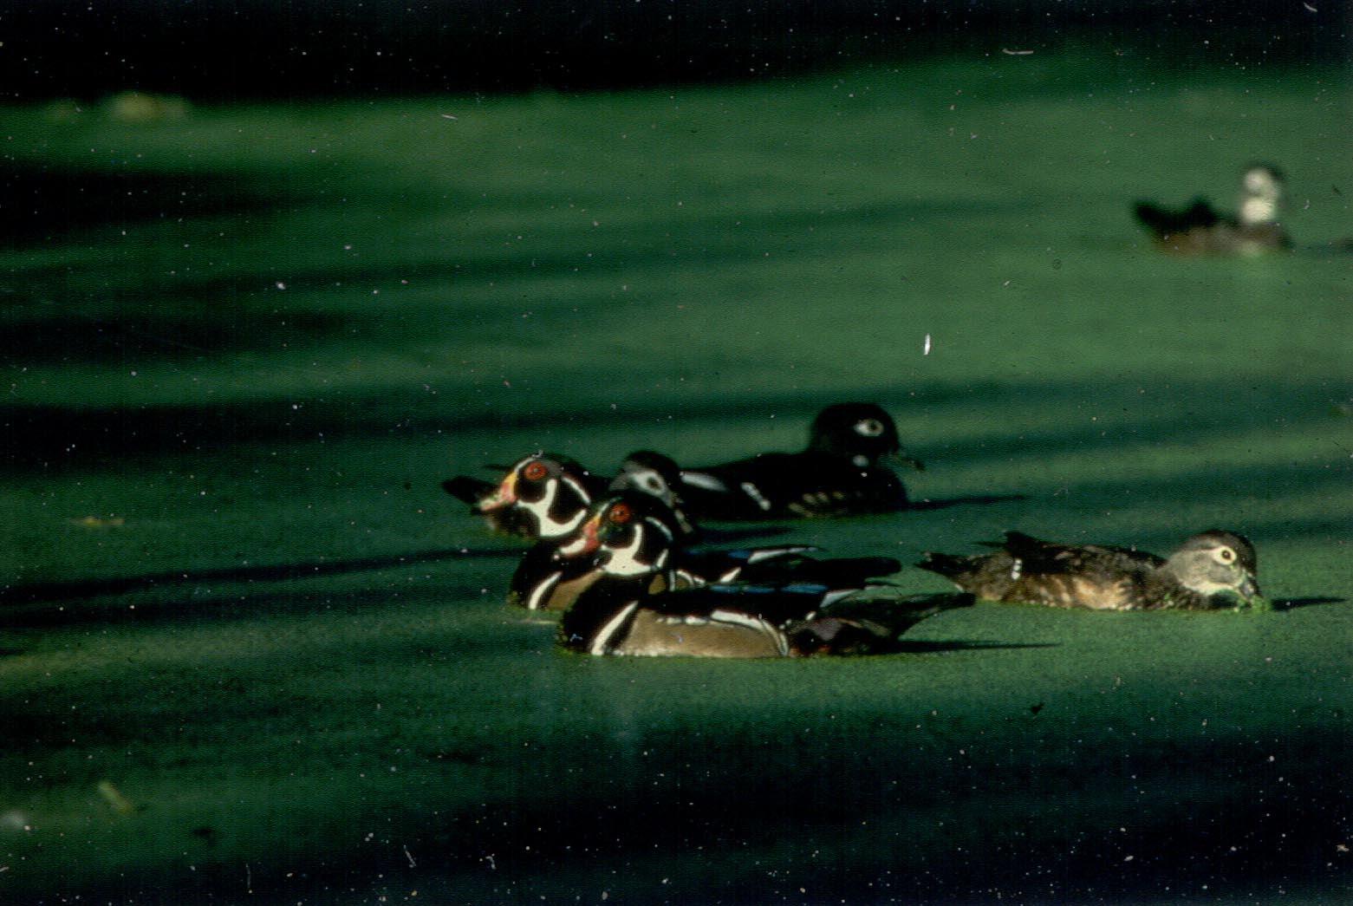
The Bayou Bartholomew watershed contains a rich diversity of both plant and animal species. The Nature Conservancy has compiled a list of species which are known to occur in the watershed (Appendix I, Table I). Additionally the Bayou Bartholomew Alliance has conducted surveys of fish species at thirteen locations since 1992. They have recorded 117 fish species in the Arkansas portion of the Bayou Bartholomew (Appendix I, Table II). Other surveys of fishes have been conducted by Thomas (1976) and Hutchins (1988). The Nature Conservancy has funded several mussel surveys and found 31 species of freshwater mussels in the Bayou Bartholomew. These mussels and fishes combine to make the Bayou Bartholomew the most diverse aquatic habitat in the southeastern United States (Ulmer personal communication 2005) and one of the most diverse sites in North America (TNC 2001). The Arkansas Natural Heritage Commission lists thirteen animal species and 18 plant species as sensitive in the watershed (Layher and Phillips 2000) (Appendix I, Table III). Two federally endangered mussel species, the pink mucket and the fat pocketbook mussels, have been found in the Bayou Bartholomew (Layher and Phillips 2000). Fish distributions and mussel distributions based on collections funded by the Nature Conservancy have been plotted to determine areas of concentration (Appendix I, Figures 1-8). Some 31 species of mussels have been found in the Bayou Bartholomew which together with the large number of fishes also occurring there makes this stream one of the most diverse stream systems on the North American continent. The federally endangered red-cockaded woodpecker is found in the watershed. Both the American alligator and the bald eagle occur in the watershed. Bald eagles are now known to nest in both Lincoln and Ashley Counties along the Bayou Bartholomew. Even small areas of wetlands or riparian habitats support an amazing array of wildlife. Local birding enthusiasts have recorded 108 species of avian fauna (Appendix I, Table IV) at the newly constructed William G. Layher Nature Trail in Pine Bluff. That trail, 1.78 miles in length traverses wetlands, floodplain hardwoods, and mixed forest habitats.
Wood ducks resting.

A variety of migrating and resident waterfowl utilize wetland resources in the watershed. These areas provide food, resting places, areas to form pair bonds, and in some cases to reproduce. In winter moist soil units, wildlife management areas, seasonally flooded hardwoods, oxbow lakes, and cypress/tupelo brakes become havens for migrating and wintering waterfowl. Mallards and wood ducks utilize recently flooded hardwoods as a source of acorns and invertebrates. Shallow wetlands provide a source of seed that is produced by herbaceous plants. Waterfowl also utilize rice fields and other artificially flooded crop fields. Seasonally flooded forests, beaver ponds, lakes and brakes provide crucial resting areas and areas for courtship activity to occur. Wood ducks and hooded mergansers nest in hollow cavities of cypress, oak and other trees in riparian zones.

Wetlands and upland sites provide for many wildlife species in the watershed. Whitetail deer, fox and gray squirrels, cottontail and swamp rabbits, wild turkeys, a variety of raptors and song birds can all be found throughout the watershed depending on species specific habitat requirements. Beaver, mink, otter, muskrat, raccoon, opossum, striped skunk, red fox, and gray fox are found commonly throughout the watershed and are often associated with forested areas close to water bodies and streams. Many reptiles and amphibians occur in the watershed, including alligators, which are dependent on water bodies and associated habitats.

Demographic and Socioeconomic Characteristics

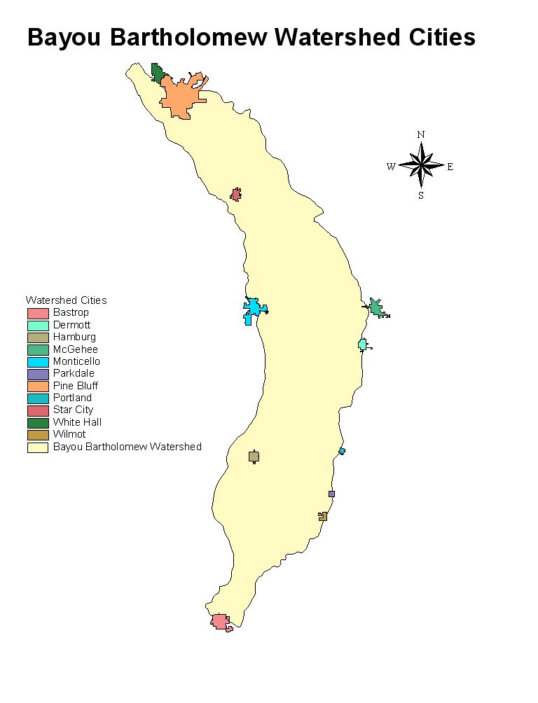
The watershed is characterized by large tracts of agricultural or timber production lands interspersed with small rural communities. Cities that occur in the watershed include Pine Bluff with a population of over 50,000 people and located at the upstream end of the Bayou Bartholomew. Other cities within the watershed include Monticello (9,146); White Hall (4,732); Star City (2,471); Dermott (3,292); and Hamburg (3,039) (U.S. Census Bureau 2000). The former two cities have boundaries which include areas outside of the watershed.

Jefferson County and Ashley County have shown decreases in population since 1990 by 1.4 percent and 0.5 percent, respectively. Drew and Lincoln Counties have experienced some population growth, though small. For instance, in the ten year period Drew County gained 1,354 individuals which is the largest growth of any county within the watershed.
Figure 7. Cities within the Bayou Bartholomew watershed.
Ninety-seven percent of the land within the watershed boundary is under private ownership (Arkansas GAP 1992). Individual ownership ranges in size from residential lots to tens of thousands of acres. Large tracts of timberland are owned by paper and timber companies. Many large farms are under the management of land trusts and are operated by tenant farmers. The majority of agricultural lands in the watershed are devoted to growing row crops such as cotton, soybeans, winter wheat, and sorghum. Rice is also grown extensively. The value of crops sold in 1997 for Lincoln County alone exceeded 80 million dollars. Confined animal operations are few; however poultry production is growing especially in Lincoln County.
State land holdings include Wildlife Management Areas which are managed by the Arkansas Game and Fish Commission. These areas include Cut-Off Creek WMA (9,080); Seven Devils WMA (4,445 acres); and the Little Bayou WMA (1,284 acres) (Arkansas GAP 1992; AGFC 2001).

The Arkansas Natural Heritage Commission owns the Byrd Lake Natural Area (144 acres) and the Taylor Woodlands (137 acres) which are both located in Jefferson County. Additionally the agency holds 900 acres of land within the Seven Devils WMA discussed above. Cane Creek State Park in Lincoln County contains a lake formed by impounding Cane Creek and covers some 1,675 acres. The Park includes 378 acres of surrounding lands (ASP 2001).
Figure 8. Public lands in the Bayou Bartholomew watershed.
Federal ownership is limited to Overflow National Wildlife Refuge in Ashley County. This 12,247 acre refuge preserves bottomland hardwood forest along Overflow Creek which is a tributary to the Bayou Bartholomew.

While agriculture and silviculture are the predominant land uses in the watershed, a relatively small work force is associated with those industries. For instance agriculture employs less than six percent of the workforce in all counties except Lincoln where it represents 11.3 percent (U.S. Census Bureau 1990). Some manufacturing occurs in especially Pine Bluff and Monticello.
Figure 9. Land ownership within the Bayou Bartholomew watershed (UARK 2004 and LSU 2004 as cited in Winrock 2005).

The percent of individuals at or below poverty level is relatively high throughout the watershed. Layher and Phillips (2001) report nearly 25 percent of the population in all counties in the watershed to live below poverty levels. Median family income is over $10,000 below the national average and median income in all cases averages less than $9,800.

Water Quality

ADEQ has designated the following beneficial uses for the Bayou Bartholomew: (1) primary and secondary contact recreation; (2) domestic, industrial, and agricultural water supply; and (3) seasonal and perennial Gulf Coastal Plain fishery and perennial Delta fishery. ADEQ assesses 359.4 stream miles in the watershed. This includes the entire channel length of the Bayou Bartholomew, in Arkansas. Also included are Cutoff Creek and Deep Bayou.

Of the 359.4 miles of stream assessed, all meet the primary contact use, secondary contact use, drinking supply use, and the agricultural and industrial use categories. Two hundred and ninety-nine and seven tenths miles meet the fish consumption use. Mercury levels preclude fish consumption in 59.7 miles of the lower Bayou Bartholomew and Cutoff Creek below Seven Devils WMA. This includes 16.8 miles of Cutoff Creek and 42.9 miles of the Bayou Bartholomew. The source of mercury contamination is not known, although similar problems exist in other watersheds throughout southern Arkansas.

The aquatic life use is only fully supported in Cutoff Creek. It is not supported in the entire length of the Bayou Bartholomew in Arkansas according to ADEQ (2002). Aquatic life use is also not supported in Deep Bayou. The aquatic life use is not supported due to siltation and turbidity (Layher and Phillips 2001; ADEQ 2002). Silt loads and turbidity are consistently high in these streams (ADEQ 2002). ADEQ’s 2008 305(b) report indicates that the entire length of the Bayou Bartholomew still does not meet aquatic life uses.

Element 1: Identification of Causes and Sources

The ADEQ recently prepared a 2008 303 (d) listing of streams in Arkansas that are impaired. All segments monitored in the Bayou Bartholomew are listed as impaired, those listed as 4a, have completed TMDL. ADEQ also prepared the “2008 Integrated Water Quality Monitoring and Assessment Report” which combines the requirements from the 305 (b) reporting, and 303 (d) listings.

Use | Support |  | Not Support
Fish Consumption | 429.6 mi | 88% | 59.7 mi | 12%
Aquatic Life | 22.7 mi | 5% | 466.6 mi | 95%
Primary Contact | 396 mi | 81% | 93.3 mi | 19%
Secondary Contact | 482.3 mi | 99% | 7 mi | 1%
Drinking Supply | 474.7 mi | 97% | 14.6 mi | 3%
Agriculture & Industry | 354.8 mi | 73% | 134.5 mi | 27%
Table 1. Shows type of use and the portion of the stream length that supports/does not support its use.

Of the twenty-one segments impaired, 8 have TMDLs, 5 for siltation/turbidity, and 2 for Mercury, and 1 for mercury and siltation/turbidity. The remaining 13 segments are impaired for one or more of the following: zinc, dissolved oxygen, mercury, pathogens, lead, copper, beryllium, chlorine, and total dissolved solids. Sources are a combination of unknown, urban and agriculture.

Two TMDLs, one for turbidity and the other for mercury, were prepared by FTN & Associates (2002). The TMDL for mercury does not identify the cause while the TMDL for turbidity assumes the cause is primarily agriculture, citing sources from the Bayou Bartholomew Alliance (1996) and ADEQ (2001a). The TMDL states that estimated load in to the entire basin at 296,960 lbs/day December –June and 59,887 lbs/day July-November. The estimated reductions for these periods are 29-37% December-June and 0-3% July-November.

The Bayou Bartholomew Alliance (BBA) also reported that other potentials sources of siltation include cropland, riparian disturbance, stream banks, construction, bed load, silviculture, and county roads. The BBA has concluded that stream bank erosion may be a large contributor of siltation and turbidity in the watershed due to the large numbers of logjams. These logjams fill with silt and become plugged by litter and trash, thus blocking stream channels entirely, causing the stream to erode around the logjams and create new channels. The primary causes of turbidity listed above have been reiterated throughout a number of state, federal and nonprofit organization reports.

Construction erosion and associated filling of wetlands within the City of Pine Bluff in the past two years has resulted in recent high turbidity levels in the Bayou Bartholomew. Large land areas uncovered without any sediment controls resulted in large movements of clay soils into the Bayou. Other construction activities included the positioning of new sewer lines longitudinally through stream channels causing massive erosion, filling of wetlands, and large silt loads to the Bayou Bartholomew (Layher 2005).

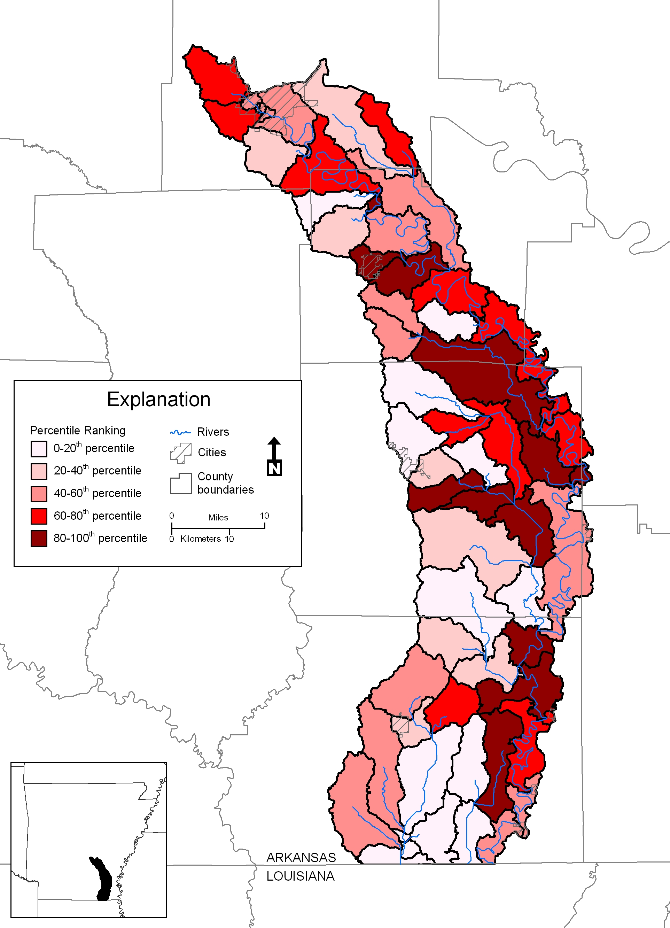
Figure 10. SWAT Model Data for Sediment (U of A 2002)

Figure 10 was created using the Soil and Water Assessment Tool (SWAT) to identify the sub-basins or sub-watersheds, which are contributing the most sediment throughout the entire watershed. Thirteen sub-basins are identified as the major sources; these basins fall within the 12-digit HUC in the following table.

Sub-watershed Name | 12-digit HUC
Upper Deep Bayou | 080402050303
Ables Creek- Panther Creek | 080402050402
Ables Creek- Bayou Bartholomew | 080402050405
Four Mile Creek | 080402050406
Cutoff Creek-Wolf Creek | 080402050508
Lake Wallace | 080402050509
Upper Overflow Creek | 080402050803
Lower Bearhouse Creek | 080402050603
Cutoff Creek- Seven Devils Lake | 080402050505
Piney Creek | 080402050503
Lower Cutoff Creek | 080402050501
Village Creek Flat Creek | 080402050403
Spring Branch | 080402050205
Table 2. Watersheds which are the in 80th-100th Percentile for sediment according to SWAT model data

Element 2 & 3: Proposed Management Measures & Estimated Load Reductions

As previously mentioned the TMDL proposed load reduction December –June is 29-37%, from 296,960 lbs/day to a maximum 199,555 lbs/day. While the load reduction July- November is proposed to be reduced 0-3%, TMDL data shows current load 59,897 lbs/day with maximum at 71,815 lbs/day.
Land Use Type | Percent of Total 1481 mi²
Forest | 54.3%
Cropland | 21.2%
Transitional | 11.0%
Grassland | 8.4%
Water | 2.8%
Suburban | 1.6%
Urban | 0.4%
Barren | 0.3%
Table3. Shows the Land Use of Bayou Bartholomew Watershed from 2006 (CAST)

Sub-watersheds that exhibit significant erosion problems or contributions to sedimentation identified by data, knowledge of conservation personnel, or modeling, should be targeted for BMP installation and focus. An evaluation of sub-watersheds should occur while work begins on those known to have significant problems related to soil loss. Using SWAT Modeling data (U of A 2002), there are 13 sub-basins or sub-watersheds, identified to be in the 80th-100th percentile for load into the entire watershed. These sub-basins cover nearly 190,000 acres, and where implementation of BMP’s should be installed, as the priority, to reduce sediment load.

Each sub-watershed should be evaluated to determine the location of areas, which are not buffered. These areas should be enrolled in appropriate conservation programs such as the Conservation Reserve Program including either grass filter strips or hardwood tree plantings. Landowners should be encouraged to establish riparian buffer strips, stabilize stream- banks, and restore riparian forests.

Landowners in sub-watersheds exhibiting the highest rates of erosion or areas that are eroding should be targeted first. Conservation planning should be accelerated in those areas to assist landowners with both technical and monetary resources to address erosion problems. Conservation plans should address BMP’s that are known to be most effective in reducing sediment detachment and transport to receiving waters. Such practices as no-till, conservation till, and drop outlets for agricultural lands. Additionally, areas suffering from gulley erosion should be examined to determine the possibility of using drop-pipes and land smoothing to reduce significant gulley erosion.

Riparian protection in areas currently forested should be addressed through the continuation of a conservation easement program to prevent erosion and stream-bank disturbance. Forestry practices which address riparian protection should be encouraged. Fencing of livestock should be encouraged through EQIP programs or others to prevent bank denuding and subsequent erosion.

Practice Code | Description | Unit | Estimated Load Reduction
329A | No Till/ Strip Till (ac) | 20,000 | 950 tons/year
382 | Fence (ft) | 12,000 | 17 tons/year
391 | Riparian Forest Buffer (ac) | 15,000 | 30 tons/year
410 | Grade Stabilization Structure (ft) | 20,000 | 6,300 tons/year
512 | Pasture and Hay Planting (ac) | 7,000 | 380 tons/year
528 | Prescribed Grazing (ac) | 7,000 | 380 tons/year
587 | Structure for Water Control (ft) | 25,000 | 8,000 tons/year
612 | Tree/Shrub Establishment (ac) | 20,000 | 40 tons/year
393 | Filter Strips (ac) | 15,000 | 9,900 tons/year
Total |  |  | 25,997 tons/year
Table 4. Proposed BMPs with anticipated load reduction

Table 4 shows the proposed BMPs needed to achieve the recommended TMDL. These values are the result of using the STEPL and Region 5 EPA Models. There is no specification in these models for the time of year and its relation to the load reduction. With this in mind, the total reduction of 25,997 tons/year translates to 142,449lbs/day, which certainly attains the reduction of 29-37%, to a maximum of 195,555lbs/day.

In addition to the implementation of BMPs, the continued removal of logjams and illegal dumps should be carried out. While it is not part of the proposed BMP implementation for reduction of sediment, it is thought that logjams cause major in-channel erosion. A geomorphic analysis of the impact of logjams on stream bank erosion should be conducted. Litter often plugs logjams and causes more severe bank erosion.

These proposed BMPs are a part of the current plan for sediment reduction to Bayou Bartholomew. As new information and technology becomes available, this plan will adapt to meet the needs of the watershed, with that may come an increase or reduction of proposed BMPs.

Element 4: Technical and Financial Assistance Needs

Finances needed to complete the required reduction in sediment load go beyond the cost of BMP implementation. This will include public outreach and education, technical assistance, and additional water quality sampling. To give an idea of the “total” cost, Table 5 shows the approximated cost over a 5-year period. Due to the unforeseeable future, limiting this implementation to 5 years may not be feasible or reasonable.

Items | Amount
Additional Water Quality Monitoring | $1,200,000
BMP Implementation | $15,798,000
Public Outreach and Education | $522,000
Technical Assistance | $650,000
EST. TOTAL COST for 5 Years | $18,170,000
Table 5. Proposed total cost for 5 years

Practice Code | Description | Unit | Cost/Unit | Total Cost
329A | No Till/ Strip Till (ac) | 20,000 | $25 | $500,000
382 | Fence (ft) | 12,000 | $2 | $24,000
391 | Riparian Forest Buffer (ac) | 15,000 | $120 | $1,800,000
410 | Grade Stabilization Structure (ft) | 20,000 | $50 | $1,000,000
512 | Pasture and Hay Planting (ac) | 7,000 | $200 | $1,400,000
528 | Prescribed Grazing (ac) | 7,000 | $7 | $49,000
587 | Structure for Water Control (ft) | 25,000 | $45 | $1,125,000
612 | Tree/Shrub Establishment (ac) | 20,000 | $120 | $2,400,000
393 | Filter Strips (ac) | 15,000 | $500 | $7,500,000
 |  |  |  | $15,798,000
Table 6. BMP practices with associated costs

The following are funding sources that are available to implement this plan.

Clean Water Act, Section 319(h) Grant Funds: Federal grant program carried out through states to reduce or abate non point source pollution. Funds can be used for BMP implementation, technical assistance, assessment, water quality monitoring, and education/outreach.

Conservation Reserve Program (CRP): This program was established as a conservation provision of the Farm Bill to encourage and assist producers who are willing to set aside highly erodable, riparian, and other environmentally sensitive lands from crop production for a 10 or 15-year period. Producers enroll in the program according to USDA program rules. If a landowner’s CRP bid is accepted, a Conservation Plan of Operation is developed. In addition to an annual CRP payment, USDA will provide a 50% cost-share to establish the selected conservation practice. Landowners may receive a maximum of $50,000 annually in CRP payments.

Wetlands Reserve Program (WRP): This voluntary program for restoring wetlands is administered by NRCS with technical assistance from the Fish and Wildlife Service (FWS). Participating landowners can establish conservation easements of either permanent or 30-year duration or can enter into restoration costshare agreements where no easement is involved. The NRCS and FWS assist private landowners with site selection and development of restoration plans. Up to 100% of the cost of restoring the wetland is provided by USDA.

Environmental Quality Incentives Program (EQIP): This USDA program works primarily in conservation priority areas where there are significant natural resource problems. High priority is given to areas where state or local governments offer financial, technical, or educational assistance and to areas where agricultural improvements will help meet water quality objectives. Landowners can apply for assistance in addressing animal waste management, erosion, and other problems. EQIP will provide up to 60% costshare for restoration. A landowner may receive up to $50,000 annually in EQIP payments.

Wildlife Habitat Incentives Program (WHIP): This is a voluntary program for landowners who want to develop and improve wildlife habitat on private lands. Participants work with NRCS to prepare a wildlife habitat development plan. USDA provides technical assistance, and cost-share up to 75% of the cost of installing the wildlife habitat practices. USDA and the participant enter into a cost-share agreement that usually lasts a minimum of 10 years.

Grassland Reserve Program (GRP): This is a voluntary program that helps landowners and operators restore and protect grassland, pastureland, and certain other lands while using the areas for grazing. The program supports plant and animal biodiversity, and grasslands and lands containing shrubs and forbs under the greatest threat of conversion.

Technical Assistance

The local county conservation districts, USDA-Natural Resources Conservation Service (NRCS), the University of Arkansas Cooperative Extension Service, and the Arkansas Natural Resources Commission (ANRC) are able to provide technical information and assistance. The NRCS can provide BMP plan and technical assistance, and develop conservation and animal waste management plans. Others entities such as Ducks Unlimited can also provide assistance through the NRCS Technical Service Provider (TSP) Program. Responsibility for monitoring water quality in Arkansas abides with the Arkansas Department of Environmental Quality (ADEQ). The Arkansas Forestry Commission (AFC) can provide expertise dealing with silviculture practices.

Element 5: Information, Education, and Public Participation

The Bayou Bartholomew Alliance should strive to provide opportunities for the public to participate in efforts to maintain the Bayou, to provide for public input into those activities and to keep the public advised of activities being implemented.

As part of this effort, the BBA should coordinate with the City of Pine Bluff, the University of Arkansas at Pine Bluff, the Cooperative Extension Service in Jefferson County, and the City of White Hall to insure that information and workshops they disseminate and hold for home builders, construction companies, and the general public. Under their municipal separate storm sewer systems (MS4) contains information targeting the importance of decreasing siltation in the Bayou Bartholomew.

The BBA should provide workshops for county road departments to address county road building and maintenance. Additional opportunities would be provided for volunteers to assist with clean-up of illegal dump sites, trash and litter. Logjam removal operations are high profile events, which often provide for public participation. The BBA should continue work with news media including newspapers, magazines, TV, and radio stations to keep the public abreast of activities and accomplishments. Tours of the Bayou, distribution of the popular BBA newsletter, and presentations to civic groups and schools are also necessary to continue public education and garner support for the restoration of the watershed.

The University of Arkansas Cooperative Extension Service also promotes environmental stewardship through promotion of effective and economically achievable best management practices. Extension agents offer conferences, workshops, seminars, environmental quality programs, and fish and wildlife programs. Assistance activities also include newsletters, bulletins, information sheets, and research reports on the website http://www.uaex.edu/.

Element 6 & 7: Schedule and Milestones

This management plan supports watershed-partnering efforts. It seeks to enhance watershed protection by fostering stakeholder input into the watershed decision-making processes. It seeks to identify NPS problems and to work cooperatively with stakeholders to resolve them. This plan is a critical component of federal, state, and local watershed protection efforts. It addresses effective and efficient mechanisms to obtain the greatest watershed benefits from limited funding. The schedule for implementation in Table 7 below shows a description of interim, measurable milestones. However, it is acknowledged that some activities and practices may change or be revised as the plan is implemented, as new or additional data and information is obtained, or funding becomes available.

Activities and Practices | Timeline | Possible Entities
Complete Watershed Plan for Bayou Bartholomew Watershed  Interim Measures:  - Incorporate stakeholder inputs and concerns into the plan  - Revise plan if water quality/other data indicates goal is not being achieved | July 1, 2009  Continuous | County Conservation Districts, NRCS, Bayou Bartholomew Alliance, Landowners, ANRC, any other stakeholders
Implement Watershed Plan BMP’s  Interim Measures:  - Identify sites, types, and number of BMPs to be installed based on available funding  - Coordinate implementation of BMPs with appropriate partners’ capabilities and expertise  - Implement appropriate BMPs to address TMDL sources and causes  - Adapt implementation of BMPs identified in this plan based on new/better information or new funding | ASAP  Continuous | County Conservation Districts, NRCS, ANRC
Provide Education and Outreach to Landowners and Stakeholders  Interim Measures:  - Coordinate partnership opportunities/resources | ASAP  Continuous | County Conservation Districts, U of A Cooperative Extension Service, ANRC
Continue to Conduct Supplemental Water Quality Monitoring  Interim Measures:  - secure funding for future monitoring  - Compile and report analyses results | Ongoing  Continuous | Ecological Conservation Organization, University of Arkansas
Table 7. Schedule and Milestones

Element 8: Performance Criteria

Management Plan implementation success evaluation will be based on:

- Achievement of Milestones
- Achieving state water quality and use standards
- Achieving TMDL standards

If the above evaluation criteria are not being incrementally achieved in a timely manner, or for the resources available/expended, a review of the plan will be conducted. The plan may be revised if different watershed issues are identified during the plan review, this management plan will be updated to address that concern. Watershed management plan assessment and monitoring will also be designed to be flexible so that load reduction targets and BMPs can be easily revised if monitoring or professional judgment indicates water quality standards are not being achieved.

Element 9: Monitoring Component

The Arkansas Department of Environmental Quality has operated monitoring stations on the Bayou Bartholomew for some time. Various types of monitoring activities have occurred. Sampling stations for water quality are given in Figure 11. Long term monitoring sites have been in operation near Ladd, Arkansas (OUA33) and near Jones, Louisiana (OUA13). Other stations are sampled bimonthly for a two-year period as part of a roving network implemented by ADEQ. These sites then remain un-sampled for a ten-year period when the roving system returns to the watershed. Sites included in this latter category are BYB01 at Highway 82, BYB02 on Highway 4 near McGehee, and BYB03 at Garrett Bridge in Lincoln County. Two tributaries also are monitored as part of the roving network. These include COC01 and COC02 on Cutoff Creek near Boydell and Monticello respectively, and OUA01151, Deep Bayou south of Grady. Some special study sites also are sampled by ADEQ for other information such as fish communities (ADEQ 2001).
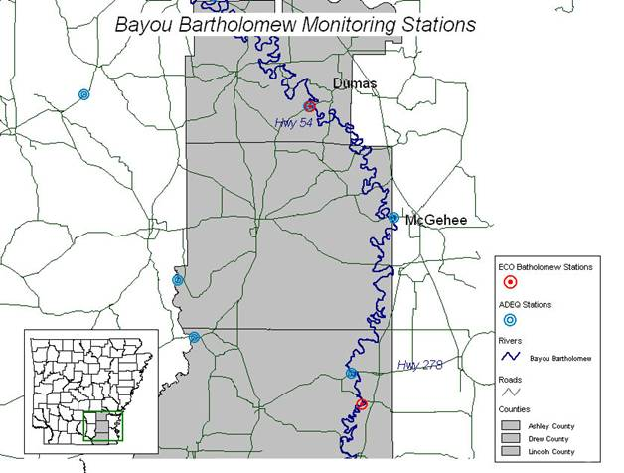
Figure 11. Monitoring stations located on the Bayou Bartholomew. (Figure from 2007 Final Report for Project 07-111.

Part of the ANRC core program contains monitoring supplemental to the ADEQ monitoring, and currently is using the Ecological Conservation Organization (ECO). ECO conducts water quality sampling, analysis, and developed a trend hypothesis for the Bayou Bartholomew Watershed by taking automated and grab samples.
ECO’s upstream site, BB1, is in the Reach ID 08040205-013 and downstream site, BB2, is in the Reach ID 08040205-002, following data is from Eco’s 2007 Project 07-116 Final Report to ANRC. The TMDLs BB1 are 3,496 lbs/day (July-Nov) and 14,478 lbs/day (Dec-June). At BB1, ECO results show daily loads exceeded these 86 and 171 times respectively. The TMDLs BB2 are 30,629 lbs/day (July-Nov) and 66,836 lbs/day (Dec-June). At BB2, ECO results show daily loads exceeded these 131 and 149 times respectively.
This supplemental monitoring with continue in this watershed to provide additional information on the state of the load entering the system. It is hoped that this data will show evidence of improvement as BMPs are implemented in the watershed.
Literature Cited and/or Reviewed

Arkansas Department of Environmental Quality (formerly ADPCE). 2000. Water Quality Inventory Report.

Arkansas Department of Environmental Quality (formerly ADPCE). 2008. Water Quality Inventory Report.

Arkansas Department of Environmental Quality. 2001. Physical, chemical and biological assessment of the Bayou Bartholomew Watershed: Ashley, Chicot, Cleveland, Desha, Lincoln and Jefferson counties, Arkansas. Little Rock, AR.

Arkansas Department of Environmental Quality. 2002. Integrated water quality monitoring and assessment report prepared pursuant to Section 305 (b) and 303 (d) of the Federal Water Pollution Control Act. Little Rock, AR.

Arkansas Department of Environmental Quality. 2008. Integrated water quality monitoring and assessment report prepared pursuant to Section 305 (b) and 303 (d) of the Federal Water Pollution Control Act. Little Rock, AR.

Arkansas Department of Natural Heritage. 2001. Inventory of Natural Areas. http://naturalheritage.com/system/

Arkansas Department of Pollution Control and Ecology (currently ADEQ). 1979. Water Quality Plan (208), Nonpoint Source Pollution Assessment Summaries.

Arkansas Department of Pollution Control and Ecology (currently ADEQ). 1996. Water Quality Inventory Report.

Arkansas Game and Fish Commission. 2001. May/June Arkansas Wildlife Magazine, Table of Wildlife Management Areas.

Arkansas Game and Fish Commission. 2001b. Arkansas Lakes and WMAs. http://www.agfc.state.ar.us/lakes-wmas/default.htm

Arkansas GAP. 1992. GIS Analysis of Arkansas GAP Data. Analysis completed 2001 by Layher Biologics RTEC, Inc., Pine Bluff, AR.

Arkansas Highway and Transportation Department. 1998.

Arkansas Soil and Water Conservation Commission. 1987. Arkansas State Water Plan, Lower Ouachita Basin. 289 pp.

Arkansas Soil and Water Conservation Commission. 1988. Arkansas State Water Plan, Arkansas River Basin. 154 pp.

Arkansas Soil and Water Conservation Commission. 1990. Arkansas Water Plan, Executive Summary. 82 pp.

Arkansas Soil and Water Conservation Commission. 1996. Assessment Update of Arkansas Nonpoint Source Pollution Assessment Report.

Arkansas Soil and Water Conservation Commission. 1998. Nonpoint Source Pollution Management Program, 1998 through 2002.

Arkansas Soil and Water Conservation Commission. 1999. Watershed restoration action strategy (WRAS) for the Bayou Bartholomew Watershed. ASWCC. Little Rock, AR.

Arkansas State Parks. 2001. Cane Creek State Park. http://www.yournet.com/canecrk.html

Arnold, M.S. 1991. Colonial Arkansas 1686-1804. Fayetteville: University of Arkansas Press.

Ashley County Conservation District. 2004. Bayou Bartholomew Watershed Non-Point source pollution abatement project. Completed for the Arkansas Soil and Water Conservation Commission.

Ashley County Ledger. 1997. November 5.

Baskett, Jr.,T. 1990. The Arkansas Delta: A Landscape of Change. The Delta Cultural Center. Helena, AR.

Bayou Bartholomew Alliance. 1996. Short and long term strategies for protecting and enhancing natural resources in the Bayou Bartholomew Watershed. Bayou Bartholomew Alliance Technical Support Group: Pine Bluff, AR.

Bayou Bartholomew Alliance. 2003. Timber management and landowner workshops. Final report project 01-2000. Pine Bluff, AR.

Broom, M.E. and J.E. Reed. 1973. Hydrology of the Bayou Bartholomew Alluvial Aquifer-Stream System, Arkansas. Progress report prepared for the US Department of the Interior, Geological Survey.

Commissioner of State Lands. 2000. Original General Land Office Survey Notes and Plats for the State of Arkansas, 1815-present. Charlie Daniels, Commissioner of State Lands.

Environmental Protection Agency. 2002. TMDLS for turbidity for Bayou Bartholomew, Arkansas. Prepared by FTN Associates, Ltd. Contract No. 68-C-99-249, Work Assignment #2-109. EPA Region VI Watershed Management Section: Dallas, TX.

Dahl, T.E. 1990. Wetlands losses in the United States, 1780’s to 1980’s. U.S. Department of the Interior, Fish and Wildlife Service, Washington, D.C.

Daniels, M. B., W. Kinkaid, and T. L. Riley. 2000. Bayou Bartholomew Water quality technical transfer project. Final report project 800. The University of Arkansas, Cooperative Extension Service.

Daniels, M. B., W. Kinkaid, and T. L. Riley. 2003. Transfer of conservation technology to agricultural land managers. Final Report Project 00-1300. The University of Arkansas, Cooperative Extension Service.

DeArmond-Huskey, R. 1996. Beyond Bartholomew: The Portland Area History. Conway: River Road Press.

DeArmond-Huskey, R. 2001. Bartholomew song: a Bayou History. Heritage Books, Inc., Bowie, Maryland. 645 pp.

Ferguson, J.L and J.H. Atkinson. 1966. Historic Arkansas. Arkansas History Commission. Little Rock.

Goodspeed Publishing Company. 1889. Bibliographical and Historical Memoirs of Pulaski, Jefferson, Lonone, Faulkner, Grant, Saline, Perry, Garland, and Hot Springs Counties, Arkansas. Goodspeed Publishing Company. Chicago, IL.

Hammond, W.R. 1945. An Abstract of Economic History of Transportation on Ouachita-Black River of Northeast Louisiana.” Ph.D. dissertation, George Peabody College for Teachers.

Hanley, S.G. 2000. Arkansas at Work, 1900-1925. Arcadia Publishing. Charleston, SC.

Hanson, G.T. and C.H. Moneyhon. Historical Atlas of Arkansas. Norman: University of Oklahoma Press, 1989.

Holland, T.W. 1999. Water Use in Arkansas, 1995. US Geological Survey, Open-file report 99-188, Little Rock, AR.

House, J. 2001. Personal communication. State Archaeological Society. Pine Bluff, AR.

Hubbel, K. and J.K. Lunon. 1990. The Arkansas Delta: A Historical Look at Our Land and People.

Kressse, T.M. and J. A. Fazio. 2002. Reprot WQ02-05-1: Pesticides, water quality and geochemical evolution of ground water in the alluvial aquifer, Bayou Bartholomew Watershed, Arkansas. Arkansas Department of Environmental Quality: Little Rock, AR.

Kresse, T., E. Van Schaik, J. Wise, and T. Huetter. 1997. Report WQ97-10-1: Occurrence of pesticides in alluvial aquifer of Eastern Arkansas. Arkansas Department of Environmental Quality: Little Rock, AR.

Layher, W. G. 2003. Assessment of fish populations of Byrd Lake. Prepared for the Arkansas Natural Heritage Commission. Layher BioLogics RTEC, Inc., Pine Bluff, AR. 9 pp.

Layher, W. G. 2003. Changes in fish community structure in the Bayou Bartholomew of southeast Arkansas as a result of watershed improvements made through 319 grant initiatives. Layher BioLogics RTEC, Inc., Pine Bluff, AR. 41 pp.

Layher, W.G. and J.P. Phillips. 2000. Determination of instream flow recommendation for the Bayou Bartholomew based on historic flow information. Contract No. 0019868 for the Arkansas Game and Fish Commission. Layher BioLogics RTEC, Inc. Pine Bluff, AR. 48 pp.

Layher, W.G. and J. W. Phillips. Bayou Bartholomew Wetland Planning Area Report. Prepared for the Arkansas State Multi-agency Wetland Planning Team. Little Rock, AR.

Lenzer, J.P. Unknown Date. Geology and Geomorphology of a Portion of the Arkansas River Alluvial Valley East of Star City, Arkansas.

Leslie, J. 1974. Saracen’s Country “Some Southeast Arkansas History.” Rose Publishing Company, Little Rock, AR.

Michael Baker Jr., Inc. 2001. Draft Environmental Impact Statement: Southeast Arkansas I-69 Connector. State Job No. 001851; Federal Project: HPC-0018(3).

Mooney, J. 2001. Personal communication. Archaeologist. Michael Baker Jr., Inc. Pine Bluff, AR.

Multi-Agency Wetland Planning Team. 1997. Arkansas Wetland Strategy.

National Agricultural Statistics Service. 1997. Census of Agriculture, Ashley County, AR. http://www.nass.usda.gov/census/census97/highlights/ar/arc002.txt

National Agricultural Statistics Service. 1997. Census of Agriculture, Drew County, AR. http://www.nass.usda.gov/census/census97/highlights/ar/arc022.txt

National Agricultural Statistics Service. 1997. Census of Agriculture, Jefferson County, AR. http://www.nass.usda.gov/census/census97/highlights/ar/arc035.txt

National Agricultural Statistics Service. 1997. Census of Agriculture, Lincoln County, AR. http://www.nass.usda.gov/census/census97/highlights/ar/arc040.txt

National Agricultural Statistics Service. 1997. Census of Agriculture, Pulaski County, AR. http://www.nass.usda.gov/census/census97/highlights/ar/arc060.txt

Natural Resources Conservation Service. 1999. Unified Watershed Assessments and Restoration Priorities, Arkansas. US Department of Agriculture.

Paulson, A.C. 1998. A Roadside History of Arkansas. Mountain Press Publishing Company. Missoula, MT.

Sacier, R.T. 1994. Geomorphology and Quarternary Geologic History of the Lower Mississippi River Valley. US Army Corps of Engineers Waterways Experiment Station. Vicksburg, MS. Volume 1.

Sheppard, D.E. 1999. Midwestern Conquest Trails – Arkansas I. http://www.webcom.com/sheppard/arkansas.html

The Nature Conservancy. 2003. Bayou Bartholomew conservation area plan.

Tomilson, M.R. 1938. Stream of History. September 11, Magazine Section. Arkansas Gazette, Little Rock, AR.

US Army. 2001. Pine Bluff Arsenal Facts Book. http://www.osc.army.mil/rm/oscfact/pba1.htm

US Army Corps of Engineers. 1973. Flood Plain Information, Part I, Bayou Bartholomew and Tributaries, City of Pine Bluff, AR. Vicksburg, MS.

US Army Corps of Engineers. 1973b. Flood Plain Information, Part II, Arkansas River, Caney Bayou and Tributaries, City of Pine Bluff, AR. Vicksburg, MS.

US Army Corps of Engineers. 1991. Southeast Arkansas, Arkansas Reconnaissance Report. Vicksburg District, Vicksburg, MS.

US Army Corps of Engineers. 2001. Mississippi River Levees, Memphis District. http://www.mvm.usace.army.mil/projects/missriver/home.htm

US Census Bureau. 1990. Labor Force Status and Employment Characteristics. http://factfinder.census.gov/home

US Census Bureau. 1990b. Income and Poverty Status in 1989. http://factfinder.census.gov/home

US Census Bureau. 2000. Arkansas – Place and County Subdivision. http://factfinder.census.gov/home

US Census Bureau. 2000b. Population Trends by County, Arkansas, 1990—2000.
http://factfinder.census.gov/home

US Department of Agriculture. 1975. Soil Survey of Pulaski County, Arkansas. Soil Conservation Service (SCS) in cooperation with the Arkansas Agricultural Experiment Station.

US Department of Agriculture. 1976. Soil Survey of Drew County, Arkansas. Soil Conservation Service (SCS) in cooperation with the Arkansas Agricultural Experiment Station.

US Department of Agriculture. 1979. Soil Survey of Ashley County, Arkansas. Soil Conservation Service (SCS) in cooperation with the Arkansas Agricultural Experiment Station.

US Department of Agriculture. 1980. Soil Survey of Jefferson and Lincoln Counties, Arkansas. Soil Conservation Service (SCS) in cooperation with the Arkansas Agricultural Experiment Station.

US Department of Agriculture. 1996. Forest Inventory and Analysis Units, Timber Product Output Database. http://srsfia.usfs.msstate.deu/scripts/twig/temp 095007 43c.htm

US Geological Survey. 1969. Water Resources Data for Arkansas, 1968, Part 1 – Surface Water Records. 175 pp.

US Fish and Wildlife Service. 2001. Overflow National Wildlife Refuge Facts Sheet. http://southeast.fws.gov/pubs/facts/ovfcon.pdf

West, E. 1987. The WPA Guide to 1930’s Arkansas. University Press of Kansas. Lawrence, KS.

Wise, Jim. 2005. Personal communication. Arkansas Department of Environmental Quality, Little Rock, AR.

Whayne, J. and W.B. Gatewood. 1993. The Arkansas Delta: Land of Paradox. The University of Arkansas Press. Fayetteville, AR.

